
AMERICAN INTERNATIONAL UNIVERSITY-BANGLADESH (AIUB)
Department of CSE
Computer-Aided Design and Drafting

Section: L
Experiment No: # 06
Name: Khan, Md. Sazzad
Id: 22–49172-3
Supervised by: MD. RAKIBUL ISLAM CHOWDHURY

Name of Experiment: Understanding and drawing Civil Plan using AutoCAD software.

AutoCAD Comments:

- How To Create Layer and Input Elements to Layer in AutoCAD:

Layer >> Enter >> new Layer >> Rename >>Apply and ok.
Then Select Objects >> Select New Layer from the Dropdown

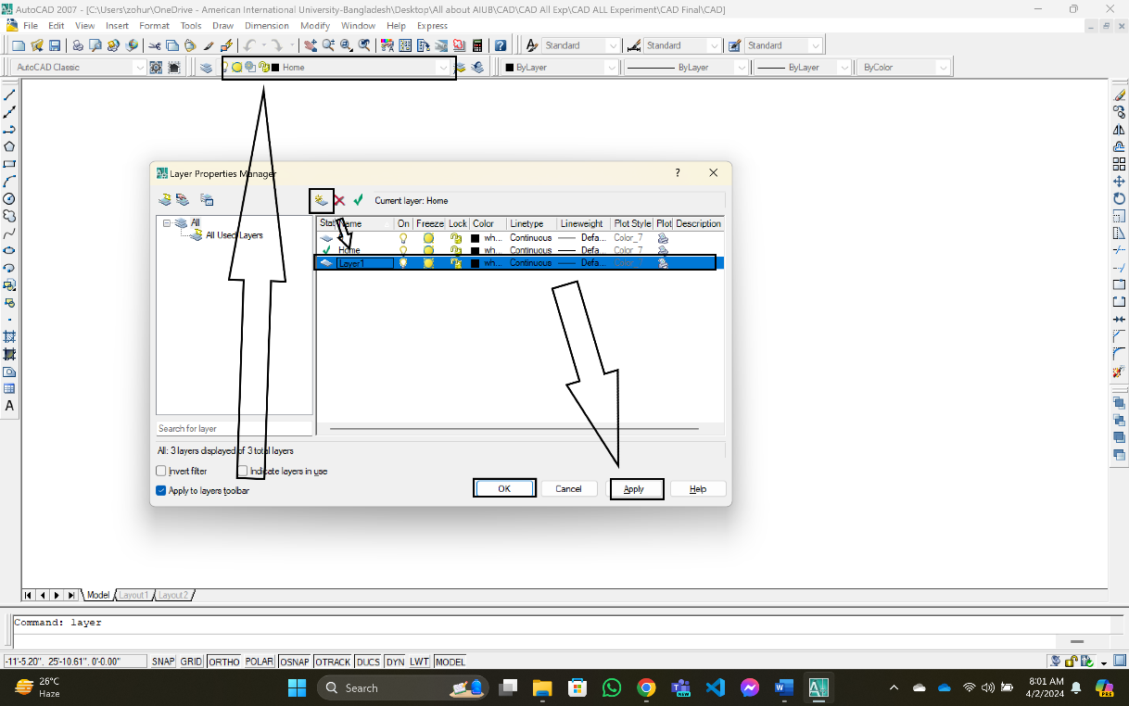

Flat Structure:

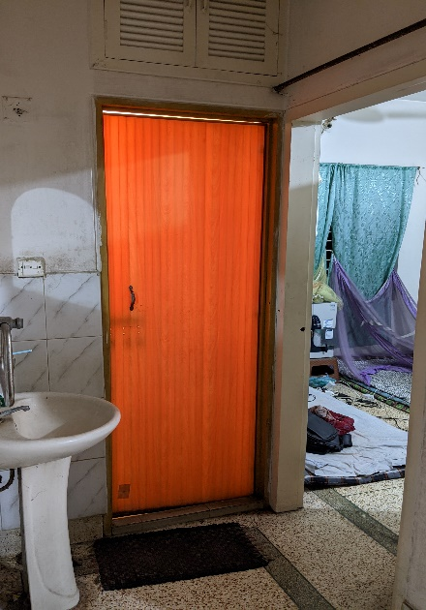
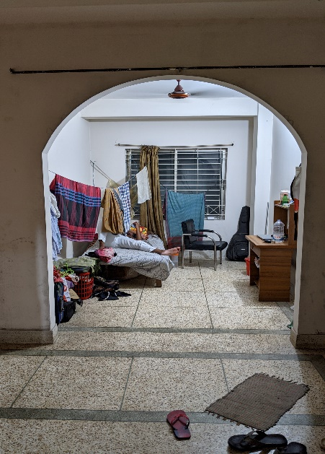
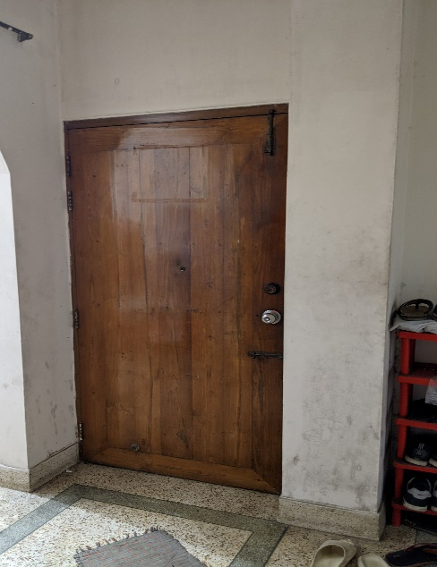
Picture - 1 Picture - 2 Picture - 3

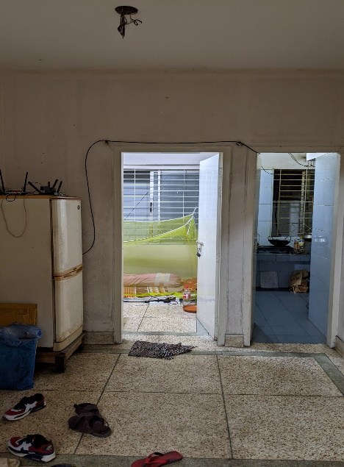
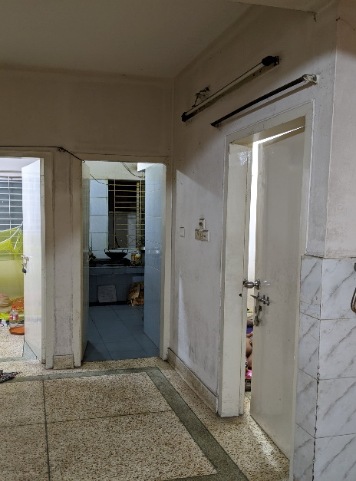

Picture - 4 Picture - 5

